LORETO GIRLS 2025 PREDICTION


(EXPECTED KCSE EXAM)
NAME……………………………………………………………………………………….
SCHOOL………………………………………….. INDEX NO………………………….
SIGN………………………………………………...

312/1
GEOGRAPHY
PAPER 1
TIME: 2 ¾ HOURS

INSTRUCTIONS TO CANDIDATES
- Answer all questions in section A.
- In section B, Answer question 6 and any other two questions from the remaining questions.
- Answer all questions using the answer booklet provided.
- Candidate should check that all pages are printed and no questions are missing.

FOR EXAMINATION USE ONLY.
 | Maximum Score | Candidate Score
Section A. | 25
Question 6 | 25
Question 7 | 25
Question 8 | 25
Question 9 | 25
Question 10 | 25
TOTAL | 100%

SECTION A
Answer all questions in this section
- (a) What is geography? (2marks)
…………………………………………………………………………………………………………
…………………………………………………………………………………………………………
(b) Give three proofs that the earth is almost spherical in shape. (3marks)
…………………………………………………………………………………………………………
…………………………………………………………………………………………………………
…………………………………………………………………………………………………………
…………………………………………………………………………………………………………

- (a) Differentiate between weathering and mass wasting. (2 marks)
…………………………………………………………………………………………………………
…………………………………………………………………………………………………………
…………………………………………………………………………………………………………
…………………………………………………………………………………………………………

(b) State three causes of landslides. (3 marks)
…………………………………………………………………………………………………………
…………………………………………………………………………………………………………
…………………………………………………………………………………………………………
…………………………………………………………………………………………………………

- Describe the formation of planet earth according to the passing star theory. (5 marks)
…………………………………………………………………………………………………………
…………………………………………………………………………………………………………
…………………………………………………………………………………………………………
…………………………………………………………………………………………………………
…………………………………………………………………………………………………………
…………………………………………………………………………………………………………
…………………………………………………………………………………………………………
…………………………………………………………………………………………………………

- The diagram below shows a coastal landform.
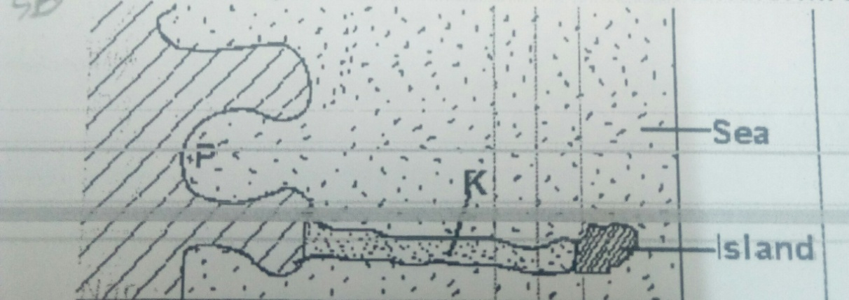
(a) Name the features marked P and K. (2marks)
P……………………………………………………………………………………………………
K……………………………………………………………………………………………………

(b) List down three types of ocean tides. (3marks)
…………………………………………………………………………………………………………
…………………………………………………………………………………………………………
…………………………………………………………………………………………………………

- (a) Name the types of earth movements that occur within the earth’s crust. (2marks)
…………………………………………………………………………………………………………
…………………………………………………………………………………………………………

(b) Describe the origin of continents according to the theory of continental drift. (3marks)
…………………………………………………………………………………………………………
…………………………………………………………………………………………………………
…………………………………………………………………………………………………………
…………………………………………………………………………………………………………
…………………………………………………………………………………………………………
…………………………………………………………………………………………………………

SECTION B
Answer question 6 and any other two questions in this section
- Study the map of Tambach 1:50 000 (sheet 90/3) provided and answer the questions that follow.
(i) Name three human features found in grid square 8260. (3 marks)
(ii) Measure the length of all-weather road loose surface C 51from the junction near the mining camp to the southern edge of the map. Give your answer in Kilometers. (2 marks)
(iii) Convert the map scale into a statement scale? (2 marks)
(iv) Give two ways through which relief has been represented in the area covered by the map. (2 marks)
(b) Draw a rectangle 15cm by 10cm to represent the area enclosed by easting 80 and 95 and northing 60 and 70. (1 mark)
On it mark and label the following features.
(i) River Kerio. (1 mark)
(ii) Lake Kamnorok. (1 mark)
(iii) Seasonal swamp. (1 mark)
(iv) Tambach Municipality (1 mark)
(d) (i) Describe the drainage of the area covered by the map. (6 marks)
(ii) Citing evidence from the map, state five functions of Tambach town. (5 marks)

- (a) Name two instruments kept in a Stevenson screen. (2 marks)
(b) The diagram below shows a weather measuring instrument. Use it to answer
the questions below.
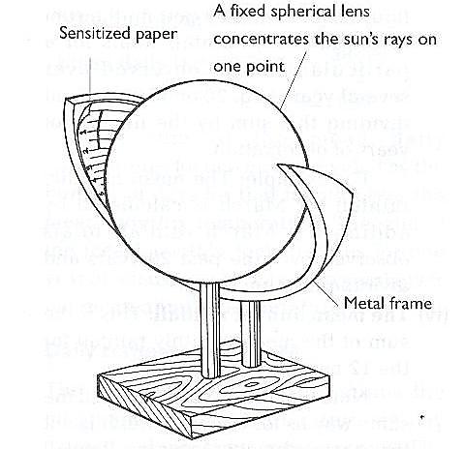
M
Metal frame
N

- Name the parts marked M and N. (2 marks)
- Describe how the instrument works. (4 marks)

(c) The table below shows climatic figure for station Q. Use it to answer the questions
that follow.

Months | J | F | M | A | M | J | J | A | S | O | N | D
Temp in ⁰C | 30 | 31 | 31 | 29 | 27 | 27 | 28 | 29 | 28 | 28 | 27 | 30
Rainfall in mm | 257 | 246 | 231 | 234 | 207 | 201 | 218 | 227 | 234 | 240 | 235 | 230

(i) Calculate the annual range of temperature for station Q. (2 marks)
(ii) Give four characteristics of climate for station Q. (4 marks)
(d) With the aid of a well-labelled diagram, describe the formation of cyclonic rainfall.(6 mks)
(e) You intend to carry out a field study of a weather station in your school.
(i) Give two methods of recording data that you are likely to use. (2 marks)
(ii) State three reasons why the recording of data at a school weather station may be inaccurate. (3 marks)
- (a) Name three types of faults: (3 marks)
(b) (i) With the aid of well labeled diagrams explain how compressional forces can lead to
the formation of a rift valley. (7 marks)
(ii) Give two examples of Horst Mountains in east Africa: (2 marks)
(c) Describe two ways in which faulting may influence drainage systems. (4 marks)
(d) A part from the Rift Valley name two other relief features that were formed
as result of faulting. (3 marks)
(e) Explain three ways in which features resulting from faulting are of economic importance: (6 marks)

- (a)(i) What is a lake? (2marks)
(ii) Name three ways through which lakes are formed. (3marks)
(iii) List three sources of Lake Water. (3marks)
(b) Describe how L. Victoria was formed. (4marks)
(c) Explain two reasons why some Lakes in the Rift Valley have fresh water. (4marks)
(d) State three economic significance of Lakes. (3marks)
(e) Students from your school intends to carry out a field study on Lakes.
(i) State two objective for their study. (2marks)
(ii) Identify two methods they will use to record the data collected. 2marks)
(iii) Which human activity might they have found to be affecting the Lakes? (2marks)

- (a) Describe plucking as a process in glacial erosion. (4 marks)
(b) Explain three conditions that lead to glacial deposition. (6 marks)
(c) The diagram below shows features resulting from glacial deposition in a lowland area.
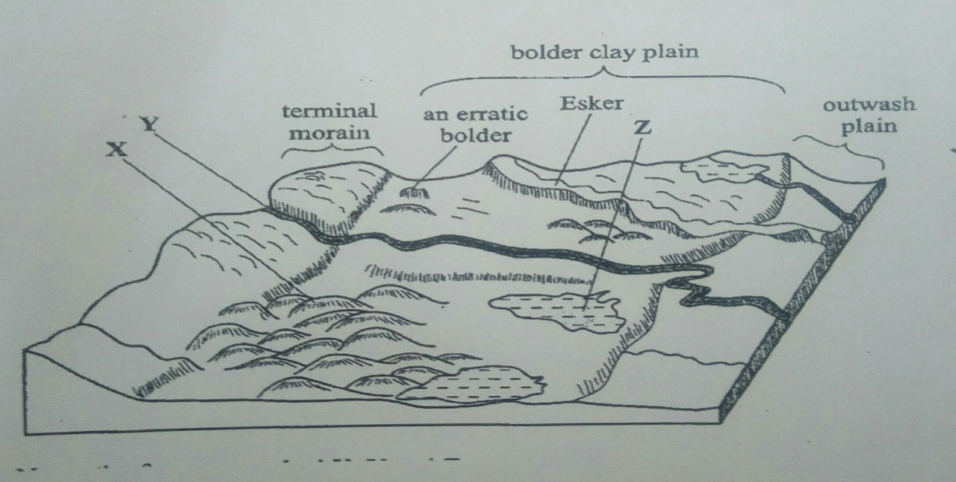
(i) Name the features marked X, Y, and Z. (3 marks)
(ii) Describe how terminal moraine is formed. (4 Marks)
(d) Explain four positive effects of glaciation in low land area. (8 marks)

